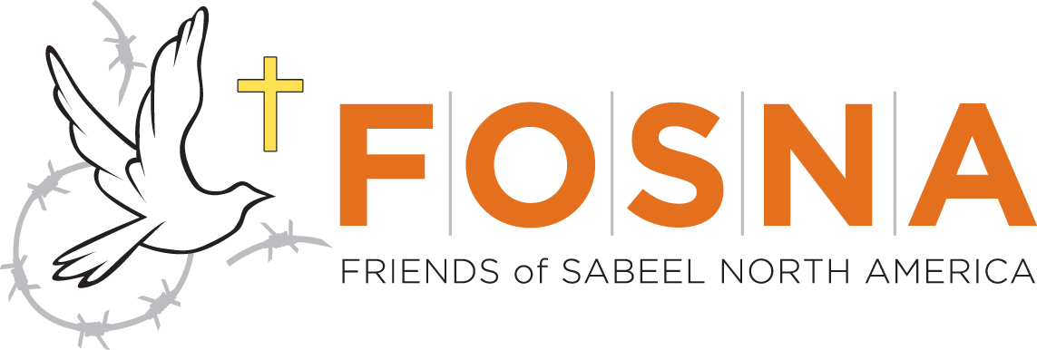

Dear Supervisor Valle:
We are co-chairs of NorCal Friends of Sabeel, a local activist group affiliated with Friends of Sabeel North America, a Christian ecumenical organization advocating for human rights, justice and peace in the Holy Land as well as North America. We are writing to express our deep concerns about the controversial Urban Shield training and weapons expo held in Alameda County. We know that funding proposals to the Bay Area Urban Areas Security Initiative will be due on October 14, and we feel strongly that the Board of Supervisors should exclude Urban Shield from any funding proposals for Fiscal Year 2017. Alameda County has an opportunity to seek funding for emergency response resources that prioritize health and wellbeing and not militarized policing. We hope the Board takes this opportunity to defund Urban Shield now.

We are both residents of Alameda County and NorCal Friends of Sabeel represents many other county residents, including clergy and members of churches. While we support Alameda County developing and increasing its capacity to respond to emergencies, we are not supportive of divisive and dangerous programs such as Urban Shield that is billed as an emergency preparedness activity. War games perpetuate racist and xenophobic stereotypes, increase the use of militarized weaponry and tactics in everyday law enforcement, and cost taxpayers millions of dollars. Since 2007, the lion’s share of funding that could be supporting emergency preparedness in the Bay Area has been poured into increasing the militarization of local law enforcement. The climate of increased police killings, militarized SWAT raids and sweeps, and surveillance technologies including drones has frayed already tattered community/police relations, destabilized neighborhoods, and broken up families across the Bay Area.
We know the impacts of prioritizing programs like Urban Shield over programs and initiatives that actually support the health and wellbeing of our communities, in times of emergency, or every day. We are particularly concerned about the impact this program has on children, young adults, people of color, and religious minorities. Urban Shield is failing our communities when it comes to preparing ourselves for the emergencies to which we are particularly vulnerable. The time has come for the Bay Area to shift its orientation toward preparing for emergencies. We insist that the health and wellbeing impacts of such preparation lead our efforts rather than go left unaddressed. UASI funding could be mobilized to support that shift.
Alameda County decision makers play an important role in determining the nature, form, and implementation of the county’s emergency preparedness. Shifting disaster preparedness priorities toward community strength and resilience and away from war games and militarization is an important way to demonstrate a commitment to shoring up preparedness without making the county’s communities vulnerable. We ask that the Board of Supervisors to use its power to restrict or approve the resources for which the Sheriff’s Department applies and receives, and reject or pull any proposal for UASI funds that include Urban Shield. We ask that you be models of new and better ways to strengthen our communities where we can come together rather than be torn apart.

Thank you for your attention and action on this important matter. As always, we would be willing to meet with you and to discuss these issues further.
Sincerely,
Rev. Ann Coburn, Co-chair John H. Erickson, Co-chair
NorCal Friends of Sabeel NorCal Friends of Sabeel

